[insert your Organization Name/Logo here]
is sponsoring a

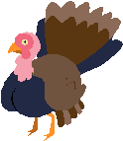
to benefit the
Turkeys (fresh or frozen) will be collected
[insert date]
at [insert drop-off location]
For more information, please call
[insert name and phone # of coordinator]
Help create a Happy Thanksgiving
for the less fortunate in Morris County!

