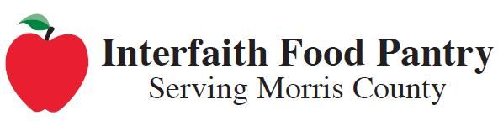**Don’t Forget,**

**When we**

**run low on food we need your help!**

**Saturday**

**May 13th!**

**REMINDER:** Your letter carrier will be picking up non-perishable groceries for our neighbors in need when they deliver your mail **on Saturday, May 13th.**

***You can help stamp out hunger and make a difference*** ***by placing canned and boxed items*** such as hearty and regular condensed soup, canned fruit, canned tuna, evaporated, dry or shelf-stable milk, pasta sauce in cans or plastic jars, and canned beans such as kidney, pinto, etc. and pasta or cereal - ***in a bag next to your mailbox.*** (Low salt and low sugar items are always welcome!)

**Donations will be given to the Interfaith Food Pantry (IFP).**

**In 2016, the Interfaith Food Pantry assisted nearly 10,000 Morris County residents and distributed more than a million pounds of food. For more information, visit www.mcifp.org.**