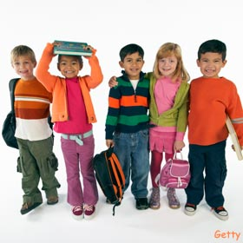
We are collecting the following school supplies and donating them to the Interfaith Food Pantry to participate in their “We’ve Got Your Back” program, to distribute new backpacks and school supplies to local families in need.

In 2017, the Interfaith Food Pantry served on average about 1,300 Morris County households struggling to put food on the table each month. When families can barely afford food, the expense of back-to-school supplies can put a strain on already tight household budgets.

Backpacks*
1” Binders
#2 Pencils (pack of 10)
Crayons (pack of 24)
Colored Pencils (pack of 10-12)*
Glue
ErasersPencil Sharpeners
Pocket Folders*
Single Subject Spiral Notebooks
Packs of Lined Paper (120)*
Pens – Blue/Black (pack of 10)
Composition Notebooks*

*Most needed

Please bring your donations to ____________ before _______________. The Pantry will begin distributing items on August 9th . Thanks for participating!

Benefitting
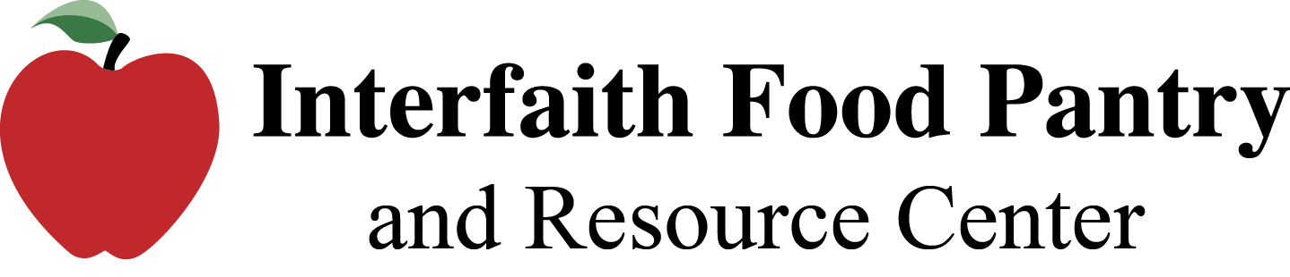
2 Executive Drive, Morris Plains, NJ 07950 973-538-8049
www.mcifp.org

